**WEEK 5**

**XSS Labs:**

1. **Stored XSS into HTML context with nothing encoded**



* Give <script>alert(1)</script> in the comment box.
* Enter any name in the name section.
* Enter any email in the email section.
* Enter any website in the website section.
* Then click on post comment.

1. **Reflected XSS into HTML context with nothing encoded.**

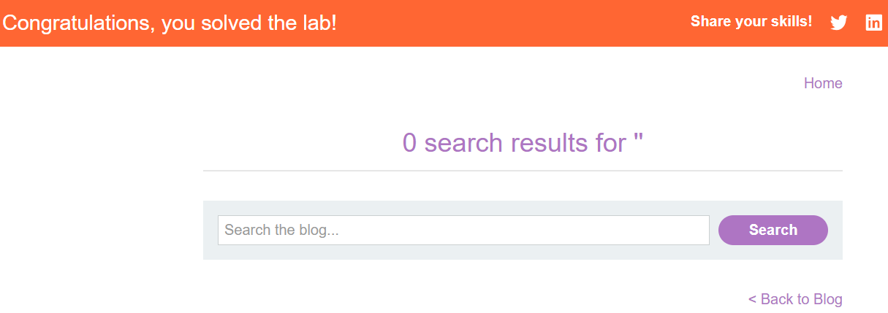

* Type <script>alret(1)</script> in the search bar and click on the “search” icon.

1. **DOM XSS in document. write sink using source location. search.**

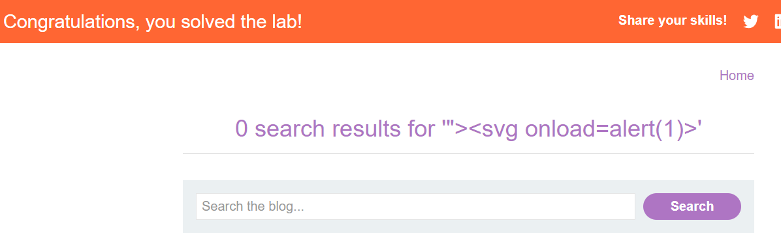

* Type a random string in the search bar and click on the “search” icon.
* Then type "><svg onload=alert(1)> in the search bar and click on the “search” icon.

1. **DOM XSS in innerHTML sink using source location. search.**

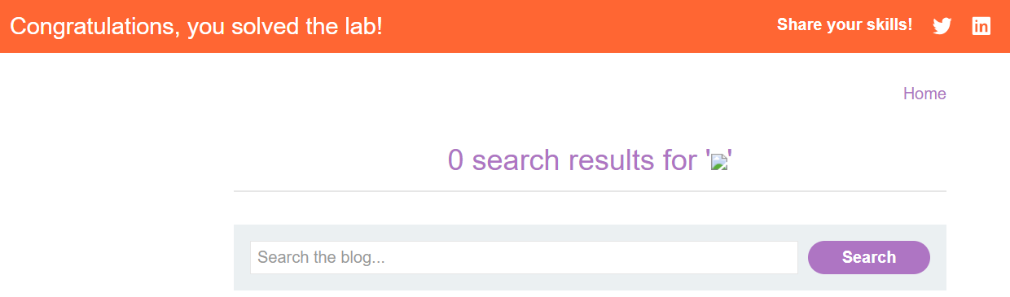

* Type <img src=1 onerror=alert(1)> in the search bar and click on the “search” icon.

1. **DOM XSS in jQuery anchor href attribute sink using location.Search source.**

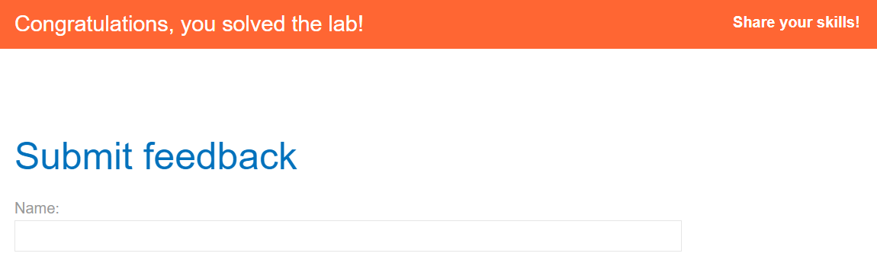

* Click on “submit feedback” and then add / any string to the URL.
* Then click on back gain and change the return path into javascript: alert(document.cookie).